Q.14) Read the scenario in the picture below, then calculate the force (F) in Newtons (N) that will just unbalance the beam. Round your answer to two decimal places.

A scale consists of a microswith that switch off the onveyor when activated by a 5 newton load. The opposite end is held by a spring with a force of 10 newtons. What force at point f is required to unbalance the beam and activate the microswitch?

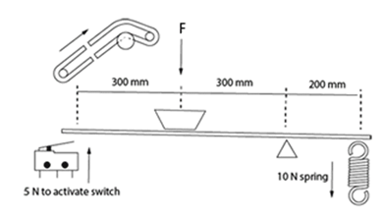

SOLUTION

Sum of clockwise force = Anti-clockwise force

F
10N
5N
R
A
B

Taking moment at point A = 0

- sum of fores in the x-direction =0 ( no component)

- sum of forces in the y-direction =0= 5 + R –F -10

- sum of moments at point A = 0= 5 X 0 –F x 300 +Rx600 -10 x 800

F=R - 5 …………………1

0 -300F + 600R -8000 =0
300F = 600R -8000
3F =6R -80 …………………2

Solving equation 1 and 2 simultaneously

R – 5 =6R -80
80-5 =6R-9
75 =5R
R=15N

F = R-5 = 15-5 =10N

